ERICH LICHTBLAU (ELI LESKLY)

PORTRAITURE OF A GHETTO LIFE

SELECTED WORKS FROM THE LOS ANGELES MUSEUM OF THE HOLOCAUST COLLECTION

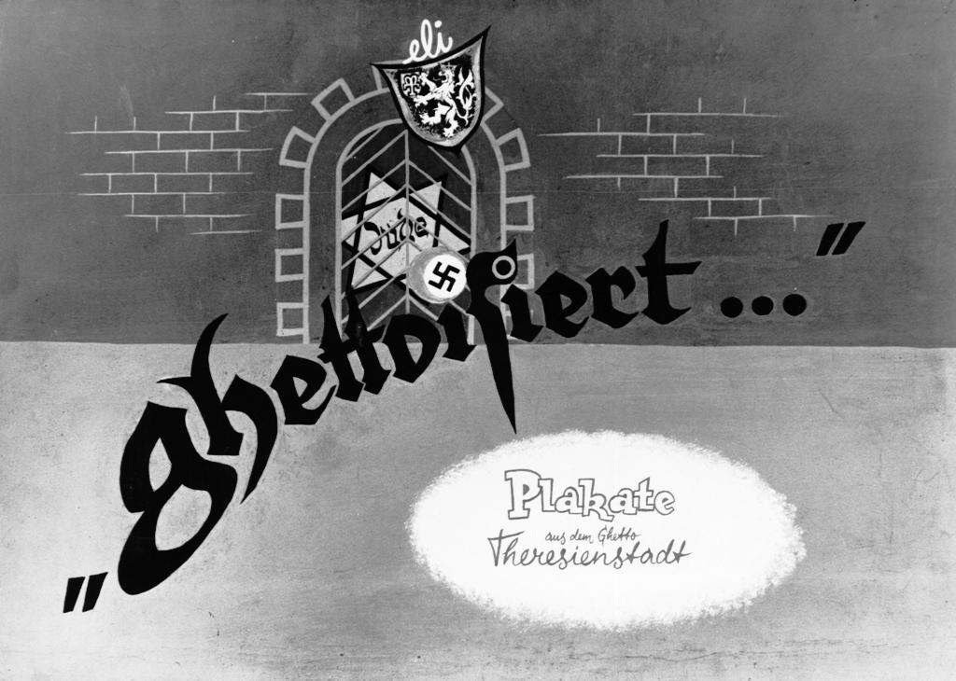

Presented by:
SECOND GENERATION OF LOS ANGLES
LOS ANGELES MUSEUM OF THE HOLOCAUST

EXHIBITS ARE LOCATED IN THE HALLWAY BEHIND THE LIBRARY

CATALOGUE IS AVAILABLE FOR PURCHASE IN THE MUSEUM OFFICE ON THE THIRD FLOOR: SUITE 303

