My First Night in the Ghetto: Overcrowded. You Need Vitamin P (Protection). Erich Lichtblau and his wife Else were deported to Theresienstadt in November 1942. Erich Lichtblau later recalls: On the picture you can see myself lying on the floor. I was sick with high fever. All the wooden bunks were occupied. I found no place to sleep. In the morning somebody said to me: “To obtain beds you need the vitamin ‘P', a privilege. The old man in the white coat was a physician in charge. The German caption Uberbelag translates as overcrowded. Terezin, 1942.
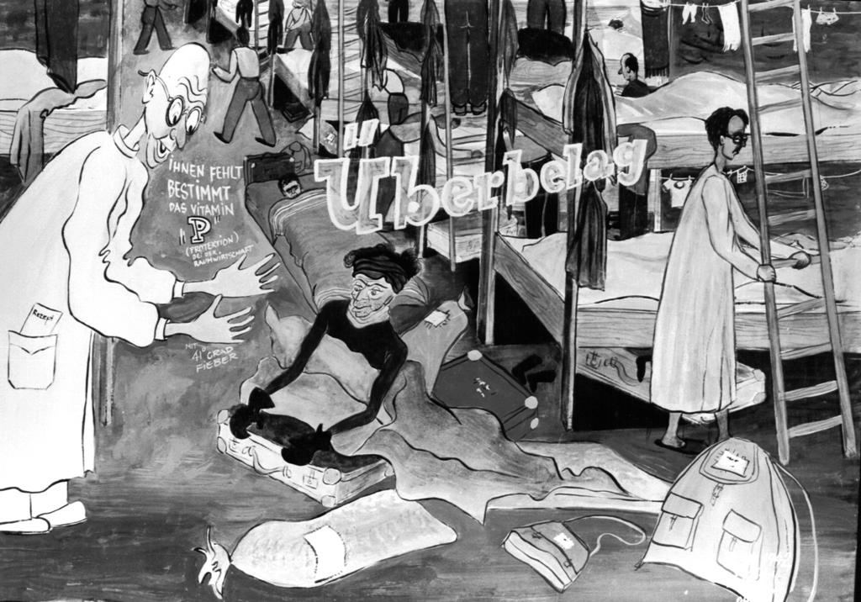
1, 1A

A View through the Window. A view from the third floor of the “Hannover Barracks” towards the Czech City of Bohušovice. The bastions and casemates are on the foreground. A town church tower is seen in the background. Terezin, 1943.
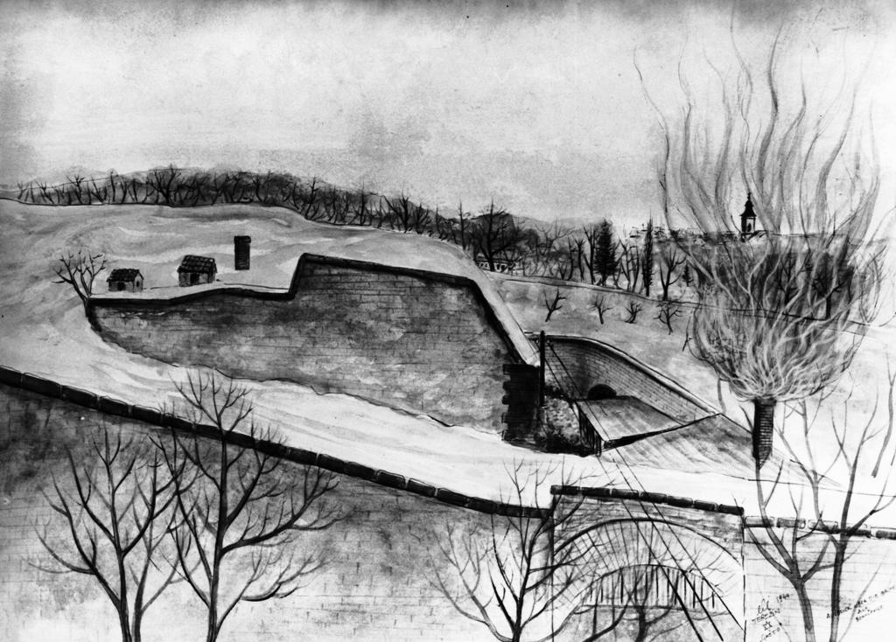
2, 2A

Prague is Free of Jews. Prag ist Judenfrei—there is no Jews in Prague. Erich Lichtblau (Leskly) comments: The Czech Jews were good patriots. Many of them had a leitmotif “Our Zion is Prague.” The Czech Jews loved their president Tomáš Masaryk and their Republic. Terezin, 1943.
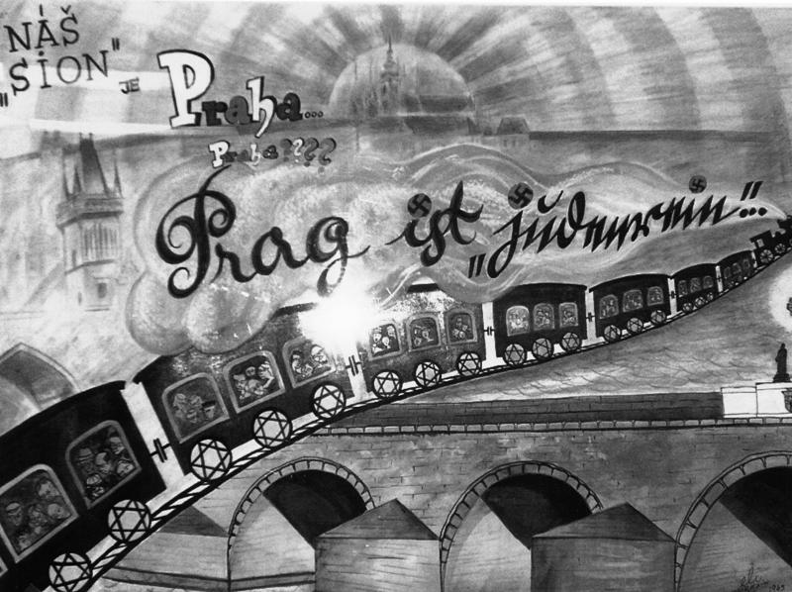

3. 3A

Bonke-Rumors from the Front-Lines. A short narrative written within the circle serves as an explanatory note: Chawer [Comrade] Paul Kohn, a Courier with the Czech Gendarmerie Station is a ‘War Correspondent.’ He tells us bonkes (rumors) from the front-lines. Terezin, 1943. 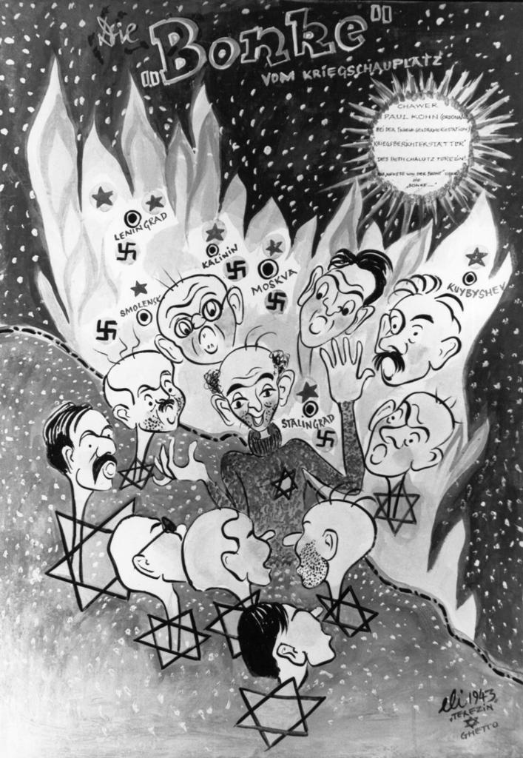

4, 4A

Jewish Order Police from the Westerbork Camp Transport. A group of Jewish deportees is transferred to Theresienstadt from Westerbork Concentration Camp. It is not clear if these Jewish deportees were the Dutch Jews or they were deported from other European countries through Westerbork transit camp. Two Jewish policemen are seen on the foreground. They wear goggles over their military caps. Apparently, these policemen came with the transport from Westerbork. Terezin, 1943. 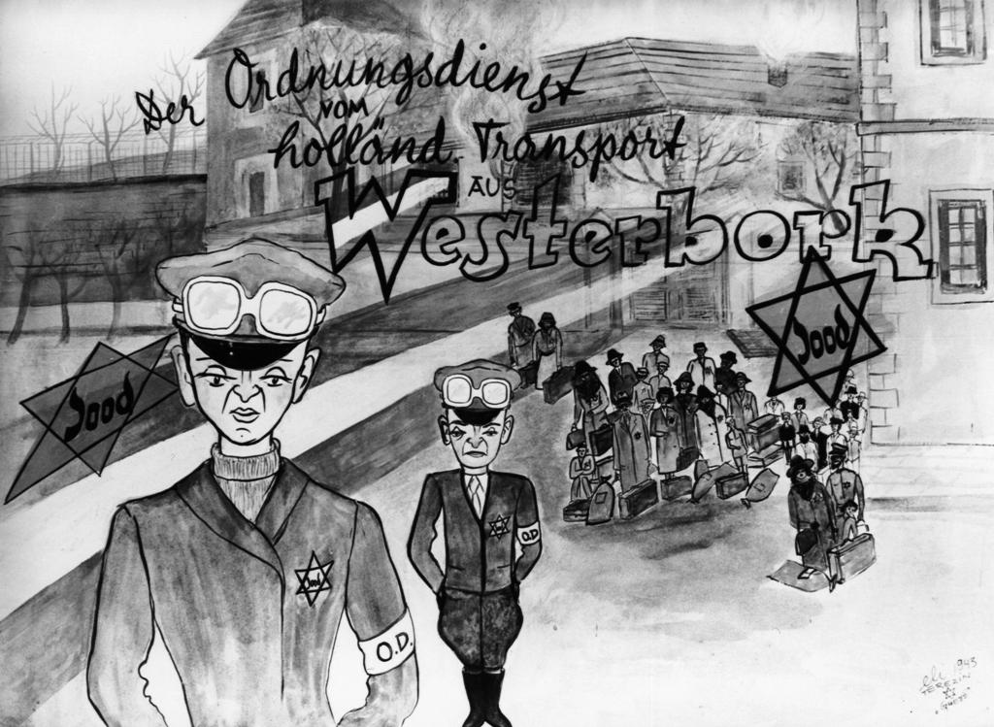

5, 5A

A Wool-Vest for a Half of Bread. This picture-story is known under the interchangeable titles: Fair Trade; A Cardigan for a Half of Bread. Leskley called it: A Hungry Old Woman Sells Clothing. It was commonly regarded that young and workable people received better rations in the ghetto than old and sick inmates. Not surprisingly a young girl on the picture is in a better shape than her fellow inmates of old age. Terezin, 1943. 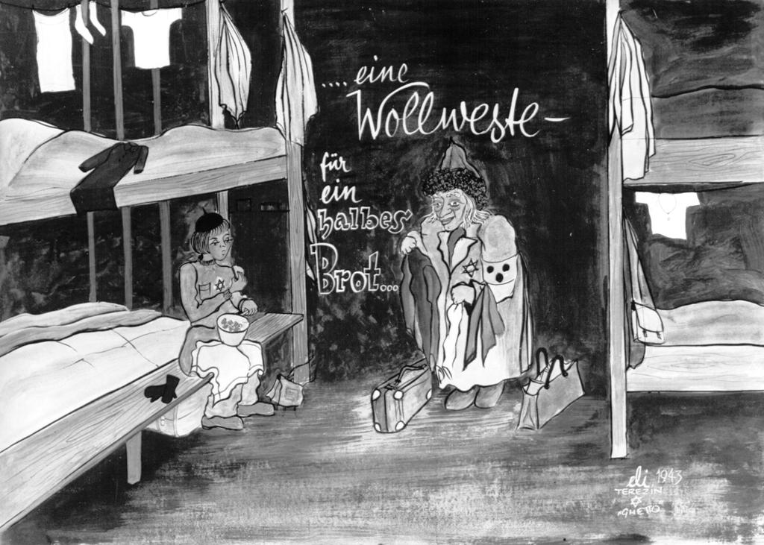

6, 6A

Her Business with Soup: Salty Lenses with Dusty Water under it. Typhoid Patients Trade with her Bread for Soup. She Asks: “Sir do You Want some Soup?” Terezin, 1943
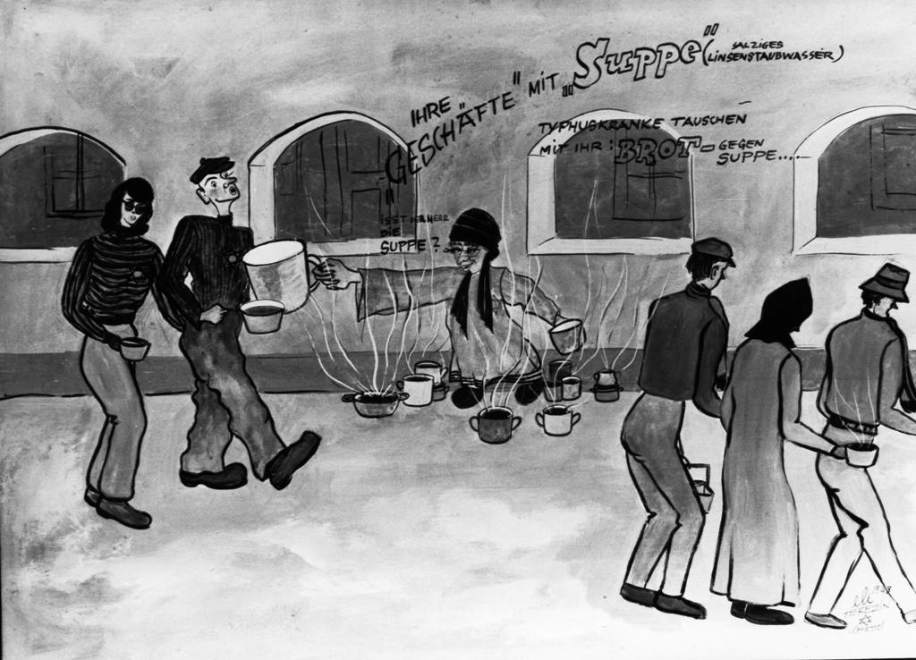
7. 7A

Permit Stamp for 10 kilo Packages from Friends and Relatives…, but only a few got Packages. Erich Lichtblau explains, it was not ordinary for other ghettos to receive packages from the outside world. In Theresienstadt, it was possible to get food parcels from family members and friends who lived in the outside world. Relatives had to get a permit-stamp. Having obtained such stamp, they could dispatch a gift parcel directed to the post office in the ghetto. Despite family and friends could send up to 10-kilo packages, only few inmates receive them. Terezin, 1943.
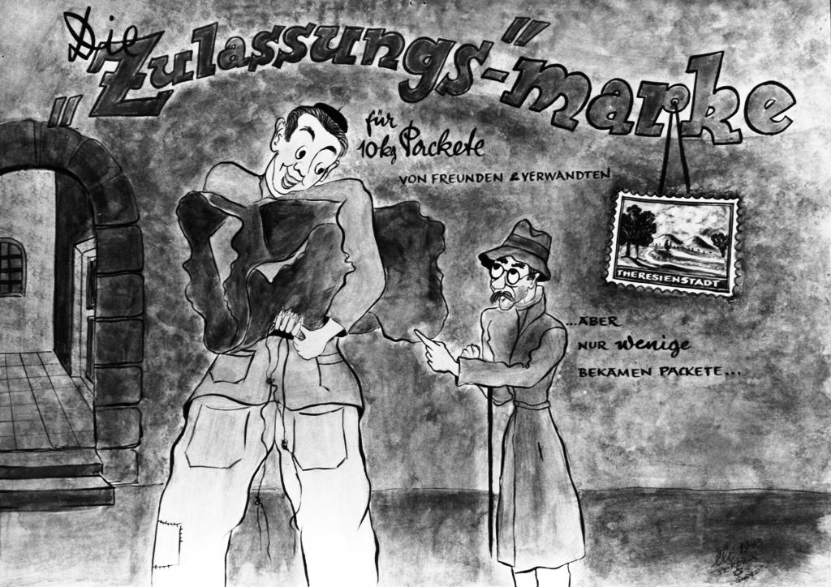
8, 8A

The Red Cross is Coming: A Happy Ghetto. Erich Lichtblau created a special picture-series about the preparation to the Red Cross Visitation of Theresienstadt. The slogan on this picture reflects Nazi deception of a “Happy Ghetto.” It reads as follows: A Happy Ghetto with Young People in the Streets, while Old and Ill Were Placed Under House Arrest. The sign on the bucket: Putzkollonne – cleaning detail. Terezin, 1944. 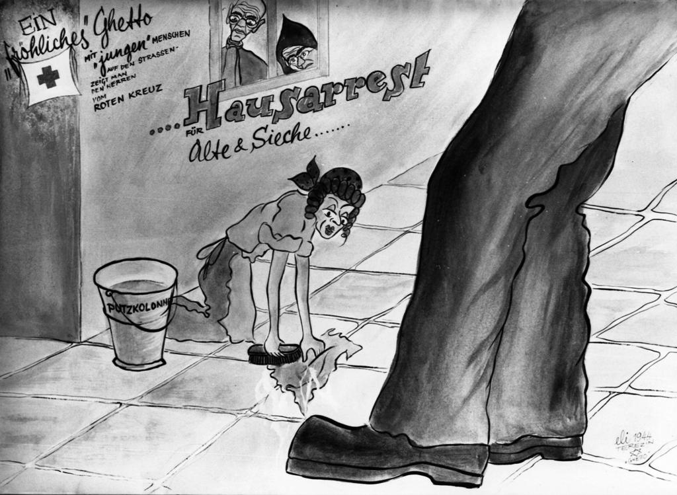
9, 9A

Smuggling Flowers into the Ghetto or Verbotenes Grün. This picture-story depicts a female ghetto-laborer carrying field flowers under her coat into the ghetto. Erich Lichtblau recalls: It was forbidden to keep flowers at home or cut them, but people did that. Vegetables were also a valuable commodity to do business with in the ghetto. Terezin, 1943. 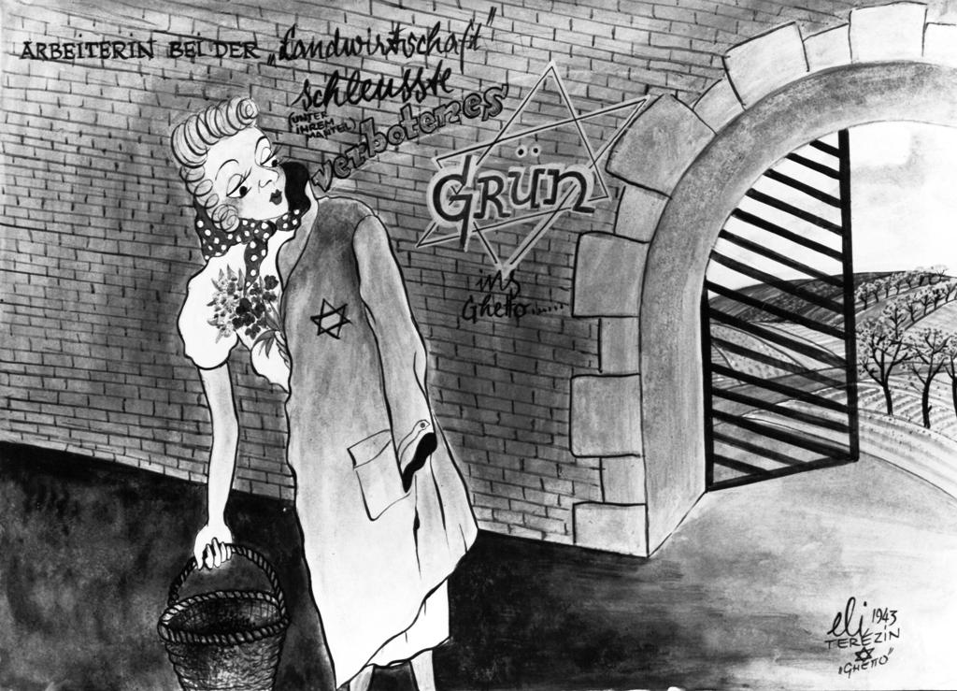
10, 10A

